Creating table for employee salary:

create table emp_salary(

    emp_id int primary key,

    emp_name varchar(20),

    salary int

);

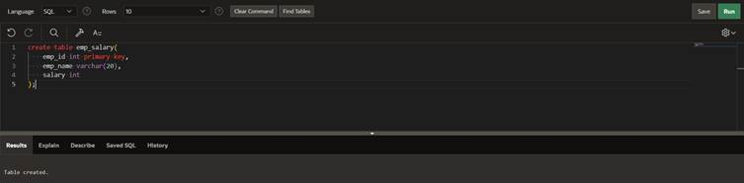

Inserting values in table:

insert into emp_salary

values(1,'rupesh',10000);

insert into emp_salary

values(2,'harshit',20000);

 insert into emp_salary

values(3,'uday',30000); 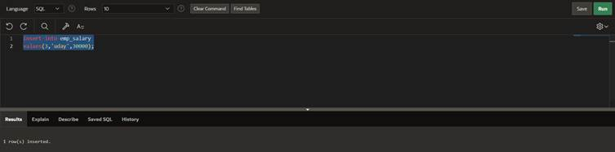

creating procedure with cursor:

create or replace procedure all_emp_raise

is cursor emp_cur is select emp_id from emp_salary;

begin

for e_c in emp_cur

loop

salary_raise(e_c.emp_id,10);

end loop;

end all_emp_raise;

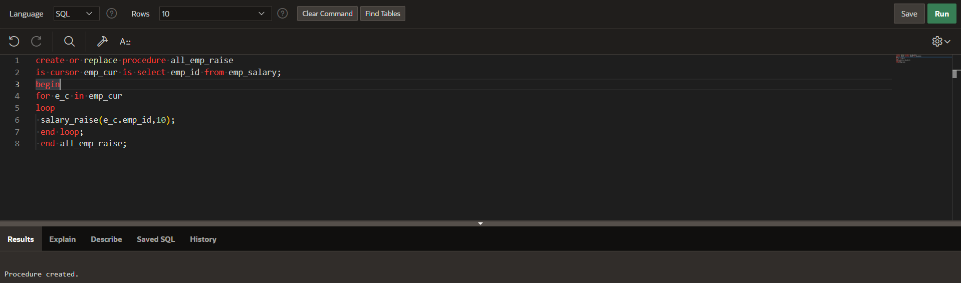

Using procedure in plsql:  
begin

all_emp_raise;

end;

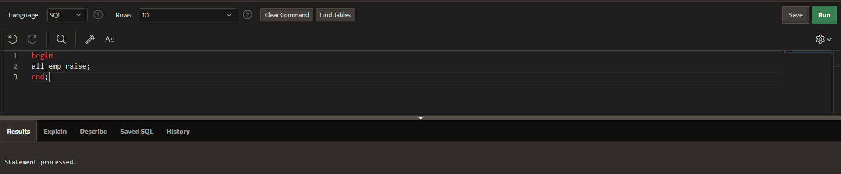

Displaying table:

select *from emp_salary;

